Masters Group Project

**Bartolomeu Bastos (2223011B)**

**Chuwkubuikem Emuwa (2200422E)**

**Chigozie Ekwonu (2228371E)**

**Patrick Gorevan (9500143G)**

**Graham Keenan (1105045K)**

**David Wright (2219383W)**

## Assumptions

* In the ModulesIn.txt, spaces in the module title are replaced with an underscore, the module code must have exactly five characters and the room should have only one character.

## Deficiencies

There are no deficiencies. The program works as requested.

## Testing

## Screenshots

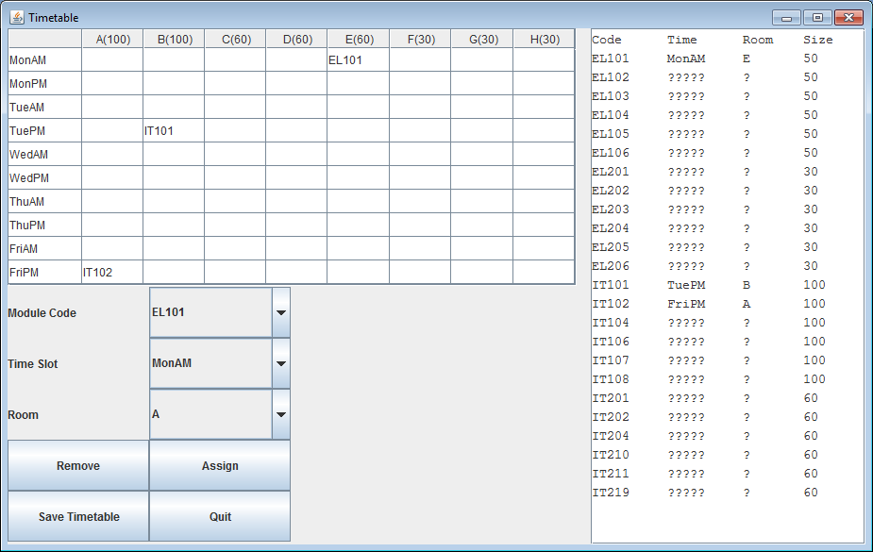Screenshot 1) Displays the timetable at the start of the program which loads the ModulesIn.txt file.

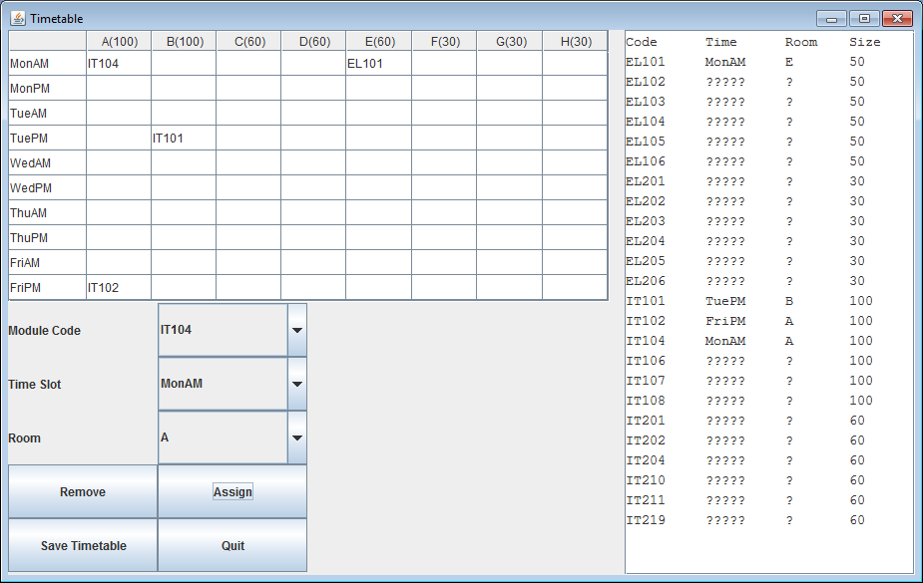Screenshot 2) Displays the timetable with module IT104 in Room A in time-slot MonAM

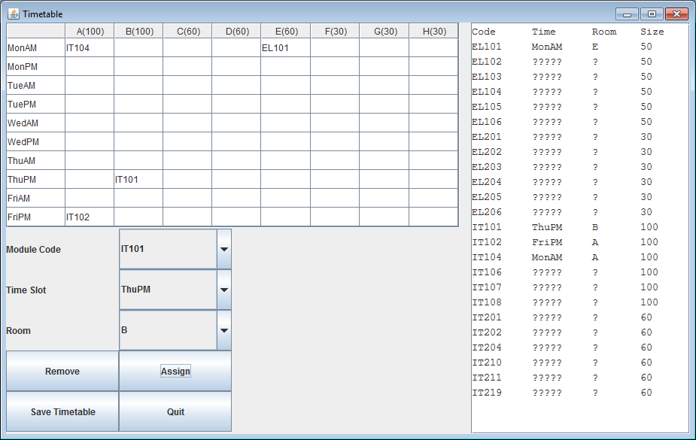Screenshot 3) Displays the timetable with IT101 moved to room B in time-slot ThuPM

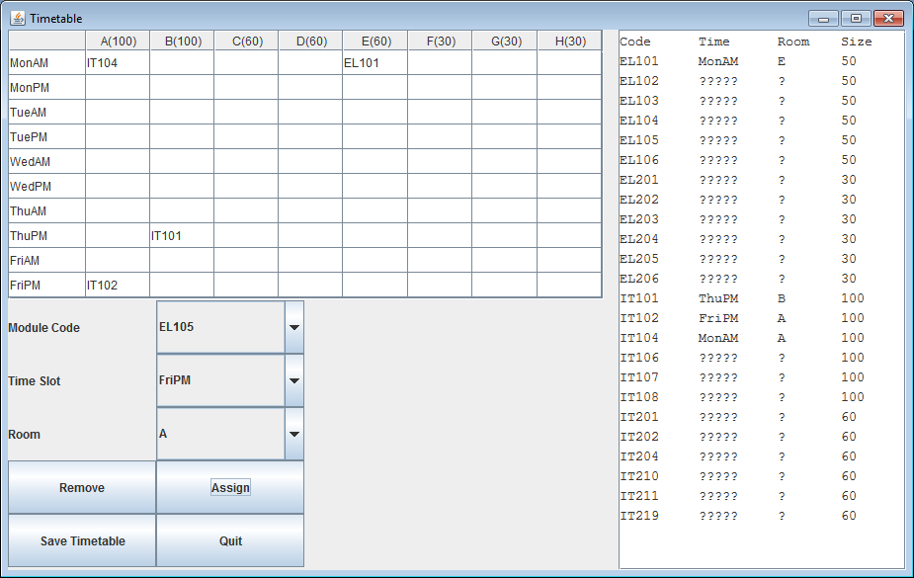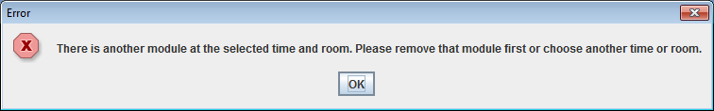Screenshot 4) An error message was displayed when we tried to move module EL105 to room A in time-slot FriPM.

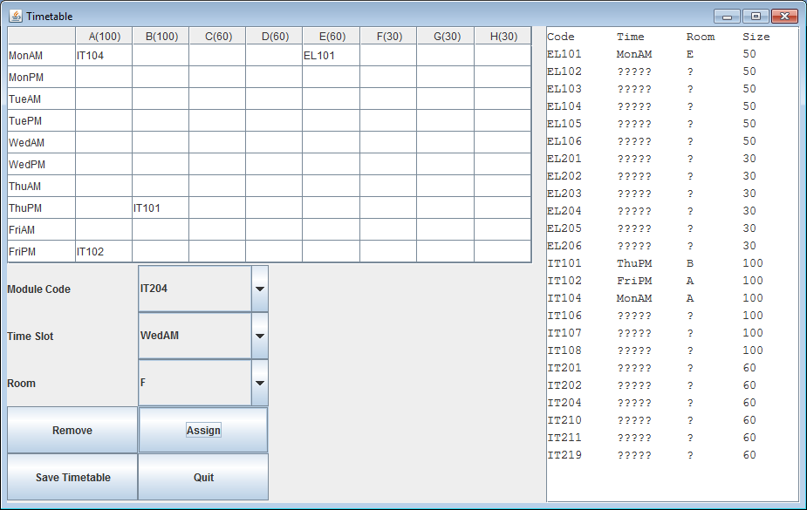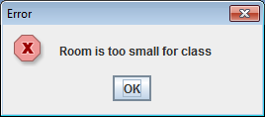

Screenshot 5) An error message was displayed when we tried to move module IT204 to room F in time-slot WedAm.

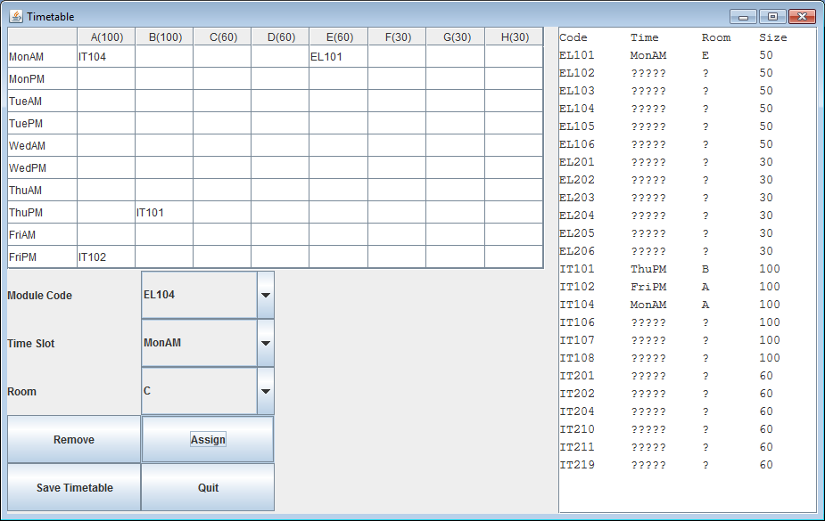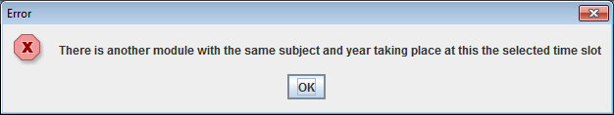

Screenshot 6) An error message is displayed when we tried to move module EL104 to room C in time-slot MonAm

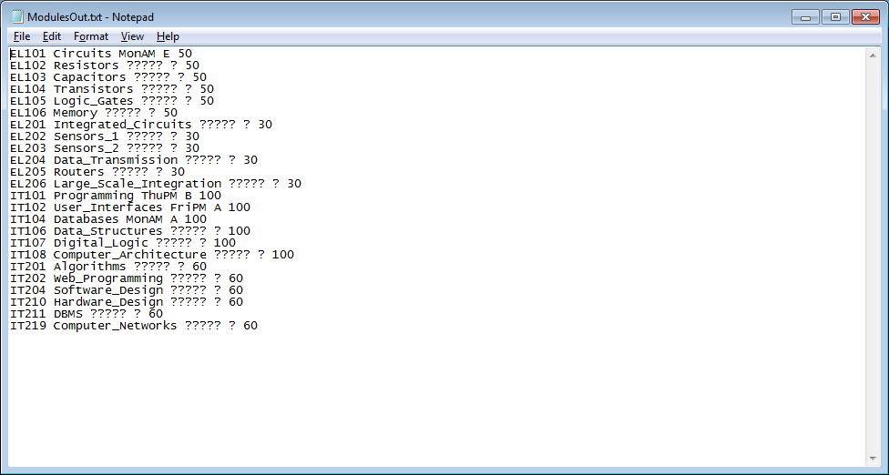

Screenshot 7) Displays the saved ModulesOut.txt file

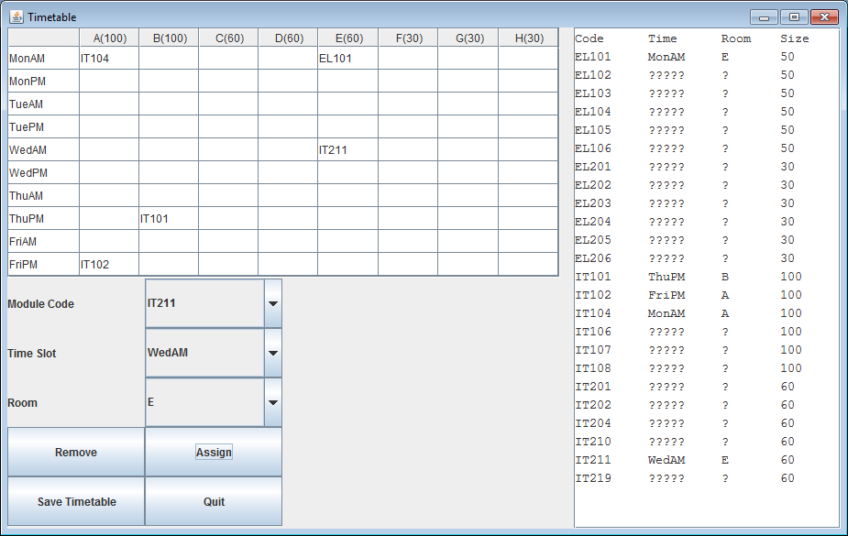

Screenshot 8) Displays the timetable after module IT211 has been moved to room E in time-slot WedAm.

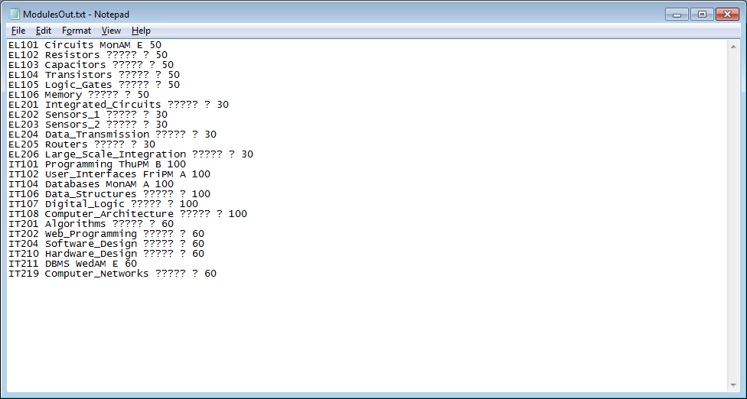

Screenshot 9) Displays the saved ModulesOut.txt